Research Methodology and Report Writing Synopsis: BBA DB 2nd yr
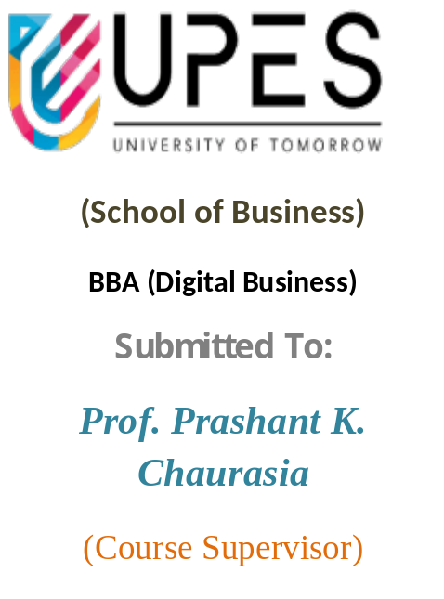
November 14

PROJECT SYNOPSIS

2025

DSRM2001_3
Authored By: Akkshhej Rawatt 590016585
Divyansh Gupta 590013621
Giriraj Agrawal 590015310
Sanidhya Deoli 590016868
Vansh Mehta 590019192

Contents
- Project Title 2
  - Introduction. . . . . . . . . . . . . . . . . . . . . . . 2
- Literature Review (What we already know) 2
  - The Good. . . . . . . . . . . . . . . . . . . . . . . . . . 2
  - Th Bad. . . . . . . . . . . . . . . . . . . . . . . . . . 2
  - What Matters. . . . . . . . . . . . . . . . . . . . . . . . . . 2
- Objectives (What we aim to find out) 3
  - To Measure. . . . . . . . . . . . . . . . . . . . . . . . . . . . . . . . . . . 3
  - To Identify. . . . . . . . . . . . . . . . . . . . . . . . . . . . . . . . . . . . 3
  - To Analyze. . . . . . . . . . . . . . . . . . . . . . . . . . . . . . . . . . . 3
  - To Recommend. . . . . . . . . . . . . . . . . . . . . . . . . . . . . . . . 3
- Sampling Criteria (Who will we study) 3
  - Explained. . . . . . . . . . . . . . . 3-4
- Data Collection (How we will get the Information) 4
  - Quantitative. . . . . . . . . . . . . . . . . . . . . . . . . . . . . . . . 4-5
  - Qualitative. . . . . . . . . . . . . . . . . . . . . . . . . . . . . . . . 4-5
- Data analysis (How we will make sense of the Information) 5
  - Tests. . . . . . . . . . . . . . . . . . . . . . . . . . . . . . . . 5-6
  - What it Does. . . . . . . . . . . . . . . . . . . . . . . . . . . . . . . . 5-6
- Interpretation of Data (What it all Means) 6
  - Conclusion. . . . . . . . . . . . . . . . . . . . . . . . . . . . . . . . 6

A Study on Indian K--12 Teachers’ Understanding and Perceptions of Artificial Intelligence in Education
Location of Study -Dehradun

Introduction

Artificial Intelligence (AI) is quickly moving into K-12 schools, changing how teachers teach and how schools operate. Teachers are at the centre of this change. They are the ones who have to figure out how to use these new AI tools in their classrooms.
This study is all about the teachers. We want to find out what K-12 teachers in Dehradun really know and think about AI. How they feel about it—whether they are excited, worried, or confused—will directly impact how useful AI can be for students. This research will look at their understanding, their attitudes, and the challenges they face.

Literature Review
Previous studies show a mixed picture. Most K-12 teachers seem to have a generally positive view of AI, but they also have some big concerns.
The Good: Teachers like that AI can make them more efficient (like helping with grading) and make learning more engaging for students (like with personalized lessons or cool visuals).
The Bad: Teachers are worried. They worry that students will become too dependent on AI and stop thinking for themselves. They are concerned about cheating, privacy, and ethics. They also wonder if it will change their own role in the classroom.
What Matters: Research also shows that a teacher's age, gender, and years of experience can change how they feel about AI. It also shows that the best training programs are the ones that focus on how to think about AI, not just which buttons to click.

Objectives
This study has four main goals:
- To find out how much K-12 teachers in Dehradun truly understand about AI and what their general opinion of it is.
- To see what factors—like age, gender, years of teaching, or the subject they teach—influence their opinions.
- To get a clear list of teachers' main concerns, hopes, and the challenges they see in using AI.
- To use all this information to give schools and policymakers real, practical advice on how to create better training and rules for AI that actually help teachers.

Sampling Criteria
To get a rich and diverse set of opinions, we will use a stratified in probability sampling and in non probability we will use purposive sampling method.
This means we won't just pick teachers at random. First, we will divide the K-12 teacher population in Dehradun into specific, important groups (called "strata"). Our key strata will be:
School Type: Public vs. Private
Experience Level: e.g., New (1-5 years), Mid-career (6-15 years), Veteran (16+ years)
Subject Taught: e.g., STEM, Humanities & Arts
After creating these groups, we will then purposively select a certain number of teachers from each group. This guarantees that our sample isn't one-sided (e.g., all new teachers or all STEM teachers) and that we get a balanced view from all key parts of the teacher population.
Inclusion Criteria: To be included in the study, a teacher must meet these criteria:
Have at least 1 year of teaching experience.

Be willing to participate in both the survey and the interview.
We will aim for a total sample size of 30 to 60 teachers. This size is large enough for our statistical tests to be meaningful, while still being small enough to conduct deep, high-quality interviews.

Data Collection
We will use a mixed-methods approach, which means we will collect two different types of data. The goal is to collect (the "what") , (the "why").
A. Quantitative Data (The Numbers)
What: A structured questionnaire (a survey) will be given to all 30-60 teachers.
Content: This survey will have two parts:
Demographics: Basic information like age, gender, years of experience, subject(s) taught, and type of school (public/private).
Perception Scales: A series of statements where teachers will rate their agreement on a 1-5 scale (e.g., "Strongly Disagree" to "Strongly Agree"). These will measure:
AI Literacy: "I feel I can clearly explain what AI is."
Perceived Usefulness: "I believe AI will help me save time on grading and paperwork."
How: This will be distributed as a simple online form (like a Google Form) or a paper copy, whichever the teacher prefers, to make it easy for them to participate.
B. Qualitative Data (The In-Depth Stories)
What: Semi-structured interviews with a large portion of our sample (e.g., at least 15-20 of the teachers who completed the survey).
How: We will use an Interview Guide with 5-7 main, open-ended questions. This gives us the flexibility to ask follow-up questions (like "Can you tell me more about that?") based

on their unique answers.
Sample Guiding Questions:
"When you hear the term 'AI in the classroom,' what's the first thing that comes to your mind?"
"Looking ahead 5 years, what is your biggest hope for how AI could help a teacher like you?"
"And what is your biggest fear or concern about it?"
"What do you feel is the single biggest barrier stopping you or your colleagues from using AI right now?"
Process: Interviews will be conducted in a private, quiet setting (or online). We will get explicit permission to audio-record and will guarantee all answers will be kept anonymous. The recordings will be transcribed (typed out) and all names/schools will be removed.

Data Analysis
We will use the SPSS software to analyse the numerical data from our questionnaire. we will try to understand our sample, we will try to conduct two main tests to find significant
relationships. We will use a standard p-value of < 0.05 or level of significance @ 5% to determine if our results are statistically significant.
The example specific tests will be:
T-Test for Difference of Means (Independent Samples):
What it does: This test is used to compare the average (mean) score on a particular question between two different, independent groups.
How we'll use it: We will use it to see if there is a statistically significant difference in perception between groups like:
Male teachers vs. Female teachers (on their average "AI Anxiety" score).
Public school teachers vs. Private school teachers (on their average "Perceived Usefulness"

score).
Chi-Square Test (χ²):
What it does: This test is used to see if there is a significant association between two categorical variables (variables that put people into boxes, like "Yes/No" or "Male/Female").
How we'll use it: We will use it to see if one category is linked to another. For example:
Is there a significant association between School Type (Public/Private) and whether a teacher has used an AI tool (Yes/No)?
Is there a link between a teacher's Subject (STEM/Humanities) and whether they are willing to receive AI training (Yes/No)?

Interpretation of Data
Finally, we will bring everything together.
We will try to explain "why" behind the quantitative survey numbers. For example, if the survey shows (from a T-test) that public school teachers are more worried, the interviews will tell us why (e.g., they might say "We have no budget for training").
We will identify which factors (like a teacher's school type or gender) are linked to different perceptions of AI.
This will all lead directly to our final recommendations for policymakers and schools in Dehradun, helping them create training and policies that are based on real evidence from their own teachers.

